Forename & Surname: | Address: | Telephone:
Circle date to collect 23rd or 24th | £10 Deposit Paid
Christmas Order Form
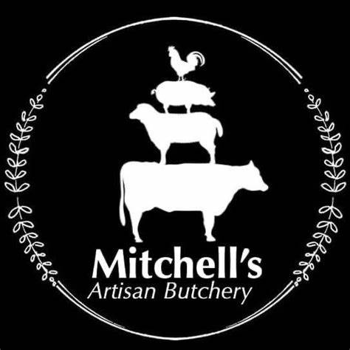
Turkey Small | 4 to 5kg
Turkey Medium | 5 to 6Kg
Turkey Large | 6 to 7Kg
Turkey X Large | 7 to 8Kg
Product | Weight | Quantity
Product | Weight | Quantity
Small | 2 to 3kg
Medium | 3 to 4Kg
Large | 4 to 5kg
X Large | 5 to 6kg
Product | Weight | Quantity
Duck Small | 1.8 to 2.3kg
Duck Large | 2.3 to 2.7kg
Goose | 4 to 6kg
Free Range Chicken | 2 to 2.5kg
Cockerel Small | 3 to 4kg
Cockerel Medium | 4 to 5kg
Cockerel Large | 5 to 6kg
Product | Weight OR Amount
Gammon Joint 1 to 6kg
Gammon Steak
Smoked Gammon 1 to 6kg
Plain Back Bacon
Smoked Bacon
Plain Streaky
Smoked Streaky
Gammon / Bacon
Other Poultry
Turkey Breast Roll
Herb Fed Free Range Turkey

Derbyshire Beef
Sausages
Product | Number/weight
Plain Pork Sausage thick
Plain Pork Chipolata
Plain Pork Cocktail
Lincolnshire Pork Sausage
Cumberland Pork Sausage
Tomato Pork Sausage
Pigs In Blanket (Trays of 12)
Product | Weight
Rib Of Beef
French Trimmed Rib
Rolled Sirloin
Rolled Topside
Rolled Silverside
Fillet Steak
Rolled Brisket
Cheese & Cooked
Free Range Pork
Product | Weight
Rolled Loin
Rolled Shoulder
Rolled Leg
Belly Slab
Pork Chops
Product | Quantity/weight
Tuxford Blue Stilton 250g
Cornish Yarg 250g
Lincolnshire Poacher 250g
White Stilton 250g
Red Leicester 250g
Boiled Ham Joint 1 to 4kg
Honey Roast Ham Joint 1 to 4kg
Mitchells Plain Pork Pie
Derbyshire Lamb
Product | Weight / Number
Leg Roast
Shoulder Roast
Lamb Chops
Rack Of Lamb

For Anything Not Specified Above Please turn over and write down what you require.
A selection of condiments and stuffings will also be available on collection.

Feel Free To Call or Email for more information.

